Military Record – #D36429

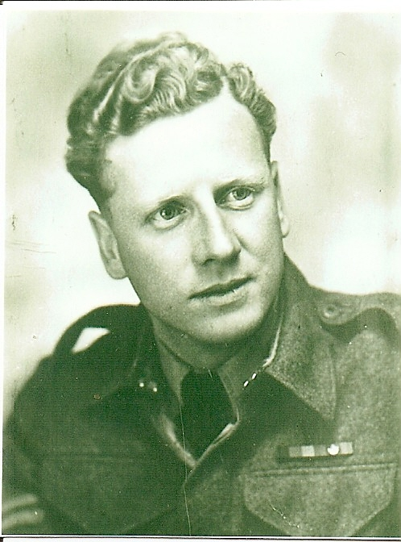

Sgt. George Jolly Smith, C.D.

Introduction:  George Jolly Smith served in the Canadian Military from 20 July 1940 to 25 October 1945, and again from 28 January 1948 to 29 January 1959. Through his service with the 12th Regiment – Three Rivers Regiment (Tank) and later with the Royal Canadian Signals Corps, George Jolly Smith earned the rank of Sergeant and the following decorations: the Canadian Forces Decoration; the Canadian Volunteer Service Medal & Clasp; the Defence Medal; the War Medal, 1939-45; the Italy Star; the France & Germany Star; and the 1939-45 Star.  This short summary of George Jolly Smith's military service was compiled from information gleaned from his official Canadian Armed Forces' military record; information taken from various Internet reference sites; and personal family recollections. Some websites are referenced in the event readers wish to seek additional information. | George Jolly Smith, C.D.

World War II (1939-1945):
At the beginning of World War II, Canada was a fully independent country and the oldest Dominion in the British Commonwealth. As a nation, it was, for the most part, reluctant to return to war; nonetheless, on September 10, 1939, Canada declared war on Germany . From a population of only 11 to 12 million, Canada eventually raised very substantial armed forces. After the long struggle of the Great Depression of the 1930s, the challenges of the Second World War accelerated Canada's ongoing transformation into a modern urban and industrialized nation. Early in the war, Canada's commitment to the British-French forces in Europe was limited to one division (3,000-5,000 personnel). Later, Canada's military deployment reached corps-level strength (30,000-50,000+) for the invasions in Italy in 1943 and Normandy in 1944. Over the course of the war, 1.1 million Canadians served in the army, navy, and air force. Of these, more than 65,000 gave their lives and another 54,000 were wounded. Countless other Canadians shared in the suffering and the hardships of war, both at home and abroad. Having suffered from nearly twenty years of neglect, Canada's armed forces were small, poorly equipped, and for the most part unprepared for war in 1939. The Permanent Active Militia (or Permanent Force (PF), Canada's full time army) had just 4,261 officers and men, while the Non-Permanent Active Militia (Canada's reserve force) numbered 51,000 partially trained and ill-equipped soldiers. Modern equipment was scarce all around. Attempts to modernize had begun in 1936, but equipment procurement was slow and the government was unwilling to expend money to equip the new tank battalions introduced that year. Nevertheless, the eventual size of the Canadian armed forces greatly exceeded those envisioned in the pre-war period's so-called mobilization "schemes". Over the course of the war, the army enlisted 730,000; the air force 260,000; and the navy 115,000 personnel.
After completing Grade IX at the Royal George School in Greenfield Park, Quebec, George Jolly Smith lived with his parents, Alfred and Jean, at 87 Fairfield Avenue, Greenfield Park, Quebec. He worked as a shipping and office clerk for Rubinivich & Haskell, an importer of "smoking sundries" on University Street in Montreal. Seeing his friends joining-up to serve King & Country, young George engaged in the Canadian Active Service Force on 20 July, 1940 – still two months shy of his eighteenth birthday. Despite a clear warning that... "any person making a false answer to any of the above questions is liable to a penalty of six months imprisonment", on his military attestation paper George claimed his birth date as October 5, 1920 (as opposed to 1922). On 22 July 1940, George was taken on strength as a Trooper with the 12th Regiment – Three Rivers Regiment (Tanks).

After basic training in Borden, Ontario, George travelled to Halifax for embarkation. He arrived in Gourock, Scotland in July 1941. While stationed in the United Kingdom, George qualified as a driver, successfully completed a radio course, and was awarded one Good Conduct Stripe and one Good Conduct Badge. He was promoted to Acting Lance Corporal on 1 January 1943 and then to Acting Corporal on 1 May 1943.
The bulk of the Canadian army overseas did not engage in sustained combat until mid-1944. Many of the young soldiers of the 1st Canadian Infantry Division, overseas since December 1939, could claim, by 1943, to have spent more of their adult lives in England than in Canada . Nevertheless, this guard duty served as a bulwark, along with British counterparts, in combating the threat from German occupied Europe during the time when the threat of invasion was at its greatest. Indeed, apart from the Dieppe Raid in August 1942 which provided important information to war planners, the frustrated Canadian Army fought no significant engagement in the European theatre of operations until the invasion of Sicily in the summer of 1943.

The Allied invasion of Sicily began on the night of 9 July 1943, and ended 17 August in an Allied victory. The invasion of the island was codenamed Operation Husky and launched the Italian Campaign. It was the largest amphibious operation of World War II in terms of men landed on the beaches and of frontage. Strategically, the Sicily operation achieved the goals set out for it by Allied planners. Axis air and naval forces were driven from the island; the Mediterranean Sea lanes were opened and Mussolini had been toppled from power. It opened the way to the Allied invasion of Italy , which had not necessarily been seen as a follow-up to Operation Husky. With the Sicily Campaign, the Canadians had the opportunity to enter sustained fighting and later they were among the first to enter Rome. | 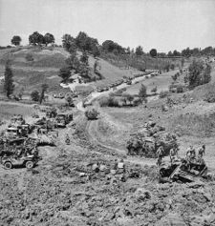  Canadian forces in Italy  advancing from the Gustav Line  to the Hitler Line.

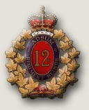 | On 13 June 1943, George was shipped out from England and arrived in Sicily on 10 July 1943. Although his military record shows no details, it is clear that the Three Rivers Regiment (Tank) played a significant role in the both the Sicily and Italy theatres of war.

From the Pachino beaches, where resistance from Italian coastal troops was light, the Canadians pushed forward through choking dust, over tortuous mine-filled roads. At first all went well, but resistance stiffened as the Canadians were engaged increasingly by determined German troops who fought tough delaying actions from the vantage points of towering villages and almost impregnable hill positions. On July 15, just outside the village of Grammichele, Canadian troops came under fire from Germans of the Hermann Goering Division. The village was taken by the men and tanks of the 1st Infantry Brigade and Three Rivers Regiment. | 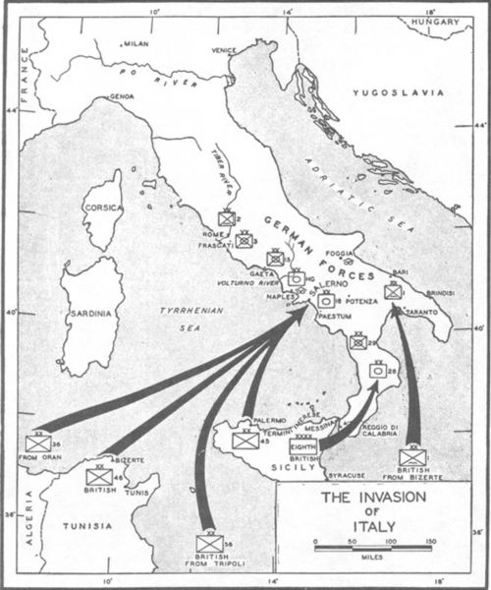  The Invasion of Italy via Sicily.

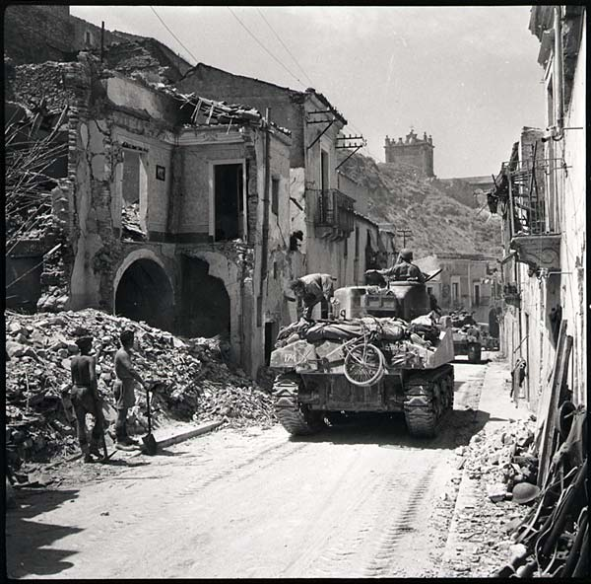  Régiment de Trois-Rivières tanks entering the ruins of Regalbuto, August 4th, 1943. | In September of that same year, George's regiment had regained Sicily and had advanced through Italy. He was confirmed with the rank of Corporal on 2 August 1943. George was appointed to Acting Lance Sergeant on 25 January 1944; however, reverted back to Corporal in April of that same year. Although the circumstances are not stated in his military record, George was awarded a Service Reprimand on 13 June 1944. Again, without mention of the circumstances, his record shows he was wounded on 25 November 1944.

On D-Day, June 6, 1944 the landings at Normandy were accomplished by two beachheads made by the American forces at Omaha and Utah, two by British forces , Sword and Gold and the final was a Canadian effort at Juno after which this spearhead drove northeast up into The Netherlands where they accomplished the liberation of that nation. The profusion of colourful tulips that grace the gardens in front of the Peace Tower in Ottawa are a thank-you gift to the people of Canada for this deliverance.

On 4 March 1945, George again boarded a military transport and disembarked in France on 6 March 1945. His military record does not detail his duties in North West Europe; however, from personal information it is known that he spent some of his quieter time billeted with the Willemyns family in Menen, Belgium.

Once again, his military record is somewhat incomplete (perhaps not unusual during the confusion experienced by a nation at war); however, it does show that George Jolly Smith arrived safely home to Montreal on 15 September 1945. Having gained experience as a "fully trained Armoured Corps soldier and crew-commander with C.A.C.", and after serving his country overseas for 55 months in the United Kingdom, Sicily, Italy, and North West Europe; George prepared to resume civilian life. In a supplement to his military record, it was noted that George Jolly Smith... "has no idea whatever as to what he will do. He expects to decide when home on disembarkation leave." Another document noted that...
"Smith is a modest, friendly, quiet spoken, well groomed young man of average height and build, 23 years of age. His service as a crew-commander with the Armoured Corps brought out his latent leadership qualities, and in spite of his age, he fullfilled (sic) all the requirements that such a position demanded. He has already arranged employment as a salesman for a commercial printing plant and is considering taking a course in night school to aid him in bettering himself in his employment. His hobby of burning designs on wood might be the basis for a course in commercial art, and by combining a knowledge of art work with printing, he may enhance his future potentialities. Smith impresses as being a level-headed and mature man with a personality that is required in the field of selling. His army occupation might be used as a basis for alternative employment such as assembler in the radio or allied trades."

Returning to his home in Greenfield Park, George Jolly Smith was discharged from active service by the Commanding Officer of Number 4 District Depot, Montreal South, on 25 October 1945. During his service "For King and Country", George earned six medals:

George Jolly Smith's Military Decorations – Wartime

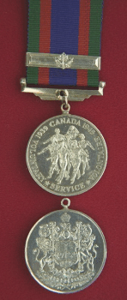 | 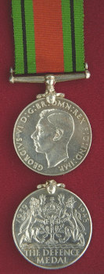 | 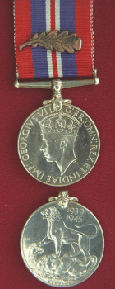 | 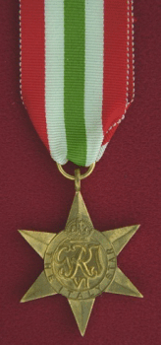 | 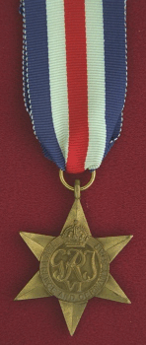 | 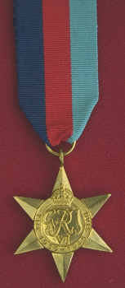
Canadian Volunteer Service Medal  Awarded for having honourably completed eighteen months (540 days) total voluntary service from September 3, 1939 to March 1, 1947.  A silver bar with a maple leaf at its centre was awarded for 60 days service outside Canada. | The Defence Medal  Awarded to Canadians for six months service in Britain between 03 September 1939 and 08 May 1945.  There was no bar to this medal. | The War Medal 1939-1945  Awarded to all full-time personnel of the armed forces and merchant marines for serving for 28 days between 03 September 1939 and 02 September 1945.  A single oak leaf emblem is worn to signify a Mention-in-Dispatches and a silver oak leaf signifies a King's Commendation for Brave Conduct. | The Italy Star  Awarded for one day operational service in Sicily or Italy between 11 June 1943 and 08 May .  There was no bar to this medal. | The France and Germany Star  Awarded for one day or more of service in France, Belgium, Holland or Germany between 06 June 1944 (D-Day) and 08 May 1945.  There was no Army bar for this medal. | The 1939-1945 Star  Awarded for six months service on active operations for Army and Navy, and two months for active air-crew between 02 September 1939 and 08 May 1945 (Europe) or 02 September 1945 (Pacific).  There was no Army bar to this medal.

Civilian Life (1945-1948):

In civilian life, George Jolly Smith worked as a salesman for a printing firm from October 1945 through May 1946. He then took a four month drafting course under the auspices of the Department of Veterans' Affairs. However, in August 1945, he ended up working as a butcher and fishmonger for the A&P Market in Montreal, Quebec – his salary was $38.00 per week. He also drove taxi for a local firm. Outside the military, George resumed his pastimes of hockey and baseball, and also found time to court his future spouse. George and Edna Elizabeth Heavyside were married on 5 July 1947. They resided at 57a Fairfield Avenue, Greenfield Park, Quebec.

Return to Military Life – "The Cold War" (1948-1959):  However, George missed the military and so, on 28 January 1948 in Montreal, Quebec, he re-enlisted in the Canadian Army (Active Force) Royal Canadian Corps of Signals. It is of note that his attestation document at that time showed his birth date as 5 October 1922, thus correcting his early "error" in 1940. His rank on re-engagement was "Signalman". |   Royal Canadian  Corps of Signals Crest

On his personnel record it was noted that...
"Smith is a modest, quiet spoken young man of average height and build, 5'8" – 139 lbs. He married in July 1947, claims to be happy. Although formal schooling is only grade IX plus a few months of business college, it is believed that Smith has substantially improved his knowledge since leaving school. Record of service is good. He was overseas for over 4 years, served in two theatres of war, deserved to be promoted to Cpl. and drew trades pay as a Radio Operator for almost 4 years. Employment record is reasonably steady and does in fact prove good stability. Smith did not however on civvy street find great satisfaction; the most important part of his adult life was spent in the Army. It has been pointed out to him that he will in the Army face a financial disadvantage at the start. Smith is athletically minded and takes an active part in the following sports: baseball, hockey, bowling. Hobby: reading technical magazines related to radio and electronic apparatus and wood carving. Smith occupies a flat with his wife. He apparently contributed a great deal of work to organize his household. Pays only $25.00 per month rent."

On re-engagement, George Jolly Smith was credited with five years, three months and nine days prior service and was immediately promoted to Signalman First Class. In October 1948, George was transferred to the RCCS training facility in Barriefield, Ontario. His record notes that... "Married, no children, Smith claims that his wife understands the reason for his going on course and offers no objection. Smith believes the course will last 9 months and hopes to be able to secure lodgings for himself and his wife in Barriefield." The following month, George and Edna moved into 5 Montreal Street, Kingston, Ontario. In December that same year, George was "Admonished for an offence under Sec 15(1) AA for being AWOL for 14 hours and 30 minutes. He forfeited one days pay for this transgression. In June 1949, George qualified as a "Radio Mech Gp 1" and on 1 January 1950 he regained his former rank of Corporal. In August 1949, George and Edna returned to "Quebec Command, HQ Signals Squadron" in Montreal.

In February 1950, George accepted a six month assignment to the Canadian Army Staff, Washington, USA. His actual posting was to the US Signals School in Fort Monmouth, New Jersey. His record notes that he was...
"nominated by his OC for a 6-month course in USA without prior referral to PSS. In a short interview this date his motivation, past employment and high learning ability suggest that he is suitable to proceed on course. He has no problem to offer – his wife is adequately housed in Montreal and will probably stay with her mother during Smith's absence. Smith is quite pleased with the opportunity to advance in his trade."

Fort Monmouth is a United States Army installation just off the coast of New Jersey, USA. The base covers nearly 1,126 acres of land and is home to several units of the U.S. Army Materiel Command that research and manage communications, computer and other technology, as well as an inter-service unit designed to coordinate communications. Other agencies, including the Federal Bureau of Investigation and the National Security Agency, have presences on the base. | 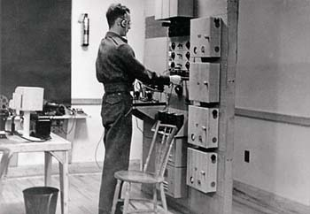  A signals instructor at work.

While away attending his US training, George's record notes... "Born a son George Randall at Westmount, P.Q." On 5 October 1950 (his birthday), after successfully completing the Teletypewriter Equipment Course (USA), George returned to Quebec Command, HQ Signals Squadron in Montreal. In January 1951, George re-engaged for an additional five years with the RCCS.

October 1952 saw George return again to Kingston, Ontario for two months and in December of that year he was promoted to Acting Sergeant. After passing his Senior NCOs Course, George was promoted to Sub/Sergeant on 4 March 1953 and finally to Sergeant on 13 July 1953. In October 1953, George Jolly Smith was posted to London, England where his residence was listed as 130 Arlington Road, Northampton, Northants, England.

On this and subsequent postings to the United Kingdom, George worked out of a top secret military base known locally as "Hanslope Park". Although still on active military service in 1953, George worked in civilian attire and travelled widely throughout Europe and the Far East.

On 22 May 1954, his record notes... "Son born, Richard Alfred, at Northampton." A subsequent entry in January 1955 shows George and Edna's residency as... "The White House, Pottersbury Lodge Estate, Pottersbury, Towcester, England." His pay in October 1955 was that of a Radio Mech Gp 3. On 23 October 1955, his record notes... "Son born, Alistair Rory" and in January 1956, George re-engaged for another three years.

Having completed twelve years active service with Canada's military, Sgt. George Jolly Smith was awarded the Canadian Forces' Decoration on 30 January 1957.
The Canadian Forces Decoration – CD  The Canadian Forces Decoration is awarded to officers and men of the Canadian Forces who have completed twelve years of service. The medal is awarded to all ranks, who must have a good record of conduct during the final eight years of claimed service. A bar is awarded for every subsequent period of ten years of qualifying service. | 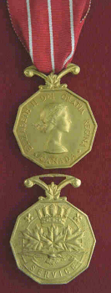

October 1957 saw another move, this time to the Oshawa Wireless Station designated "Camp-X" by the Canadian Military.

Camp X was established December 6, 1941, for the purpose of training American OSS (forerunner to the CIA) agents to be dropped behind enemy lines as saboteurs and spies. Later, British, Canadian and other Allied secret agents were schooled in a wide variety of special techniques including silent killing, sabotage, partisan support & recruitment methods for resistance movements, demolition, map reading, skilled use of various weapons, and Morse code. Legend has it that the trainees included Ian Fleming, later famous for his James Bond books.  In the fall of 1945 Camp X was used by the RCMP as a secure location for interviewing Soviet embassy cypher-clerk Igor Gouzenko who defected to Canada September 5 and revealed an extensive Soviet espionage operation operating in the country. | 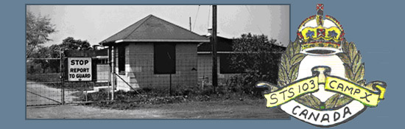  Original 1940s' Camp 'X' gatehouse.  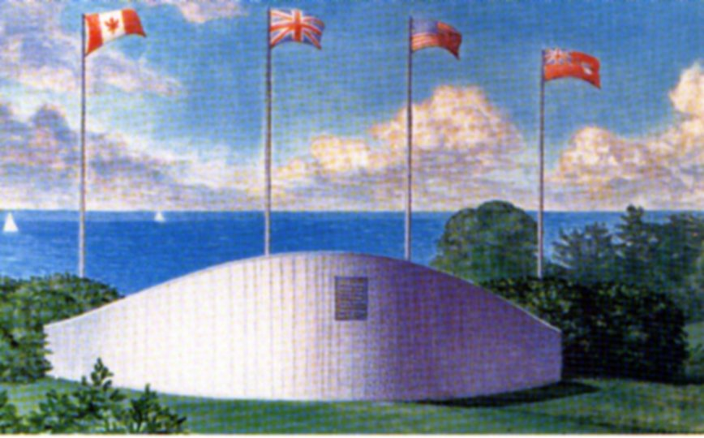  Present day memorial to Camp X  in Whitby, Ontario – near the shores  of Lake Ontario.
On arrival at Camp X, George, Edna and their first four children (Randy, Rod, Rick and Ror) rented a house at RR#3 Bowmanville, Ontario due to a lack of available Personal Married Quarters on the base. In August 1958, George and Edna moved into a PMQ at Camp "X". Their postal address was simply "PO Box 427, Oshawa, Ontario. On 14 November 1958, Sgt. George Jolly Smith was transferred (at least on paper) to "6 PD Toronto" where, on 29 January 1959, he was "Honourably Released" under General Regulations (Army) 15.01 Item 4(g).

A Civilian Once Again:

George Jolly Smith left the Canadian Military to join the Department of External Affairs which required personnel of his experience for secure communications between Canadian Embassies and High Commissions around the world. He remained with External Affairs until his retirement in 1975. George's work with "External" took him around the world and.... – well, that is another story!

As noted above, on completion of his military service, George Jolly Smith continued to serve Canada in a civilian role. After his retirement from the Federal Public Service,
George worked with the Canadian Corps of Commissionaires, an organization dedicated to the security of various Federal buildings and personages. He was later enticed back on a temporary basis to the Department of External Affairs. On March 22, 1983, George succumbed to a heart attack at his home in Aylmer, Quebec. In his sixty-first year, George left behind Edna, his spouse of thirty-six years; six children and several grandchildren. | 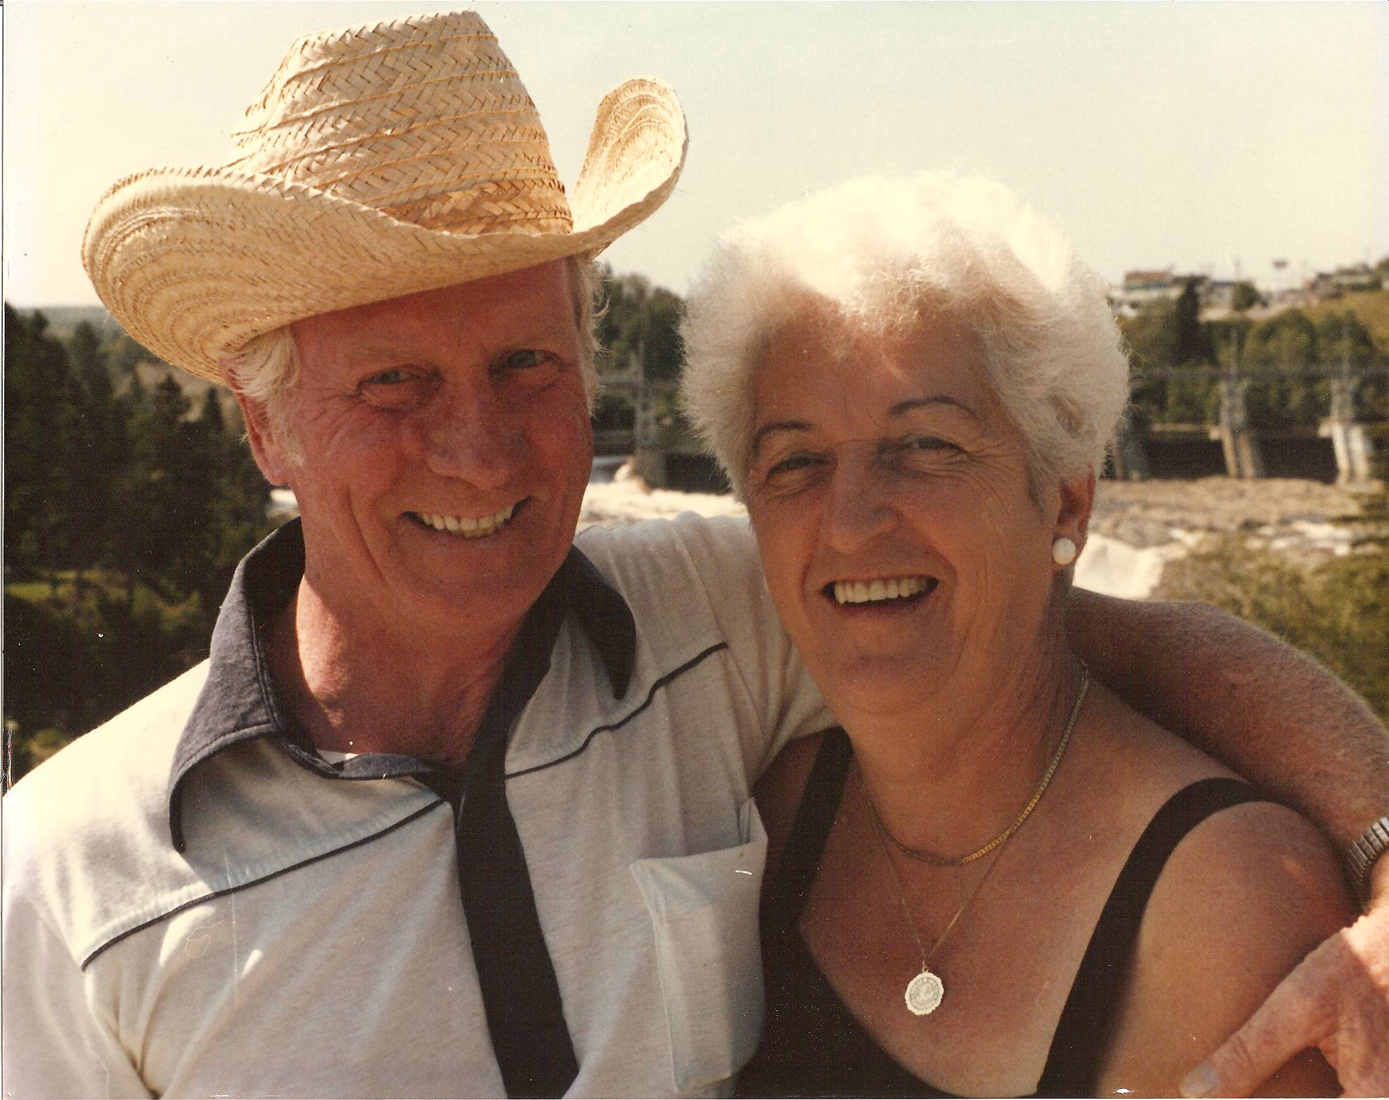  George & Edna in the summer of 1981.

Service Completed – Soldier Laid to Rest:

George Jolly Smith is buried in the Belleview Cemetery in the Aylmer district of Gatineau, Quebec, near Canada's national capital. This site is adjacent to a number of golf courses and just down the road from his last residence at 29 Place Louisbourg.

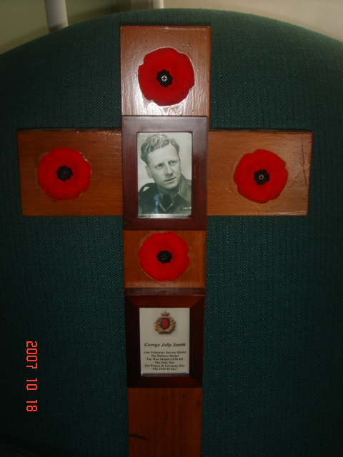  George Jolly Smith, C.D.  Recognized by his family,  for services rendered to his country and... | 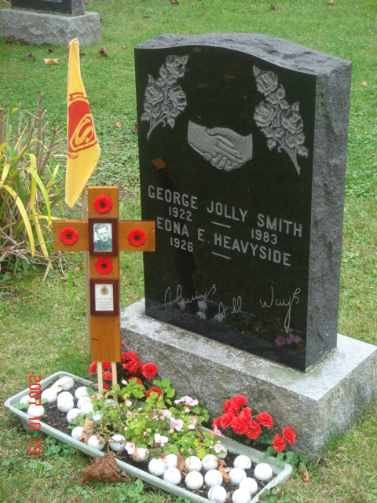  ...also recognized –  for his lifetime passion for golf –  by his children and grandchildren.

Completed: November 2007

Prepared by: Rod Smith

Assisted by: Edna E. Smith
National Archives Canada – Geneology Section
Wikepedia... the Free Encyclopedia websites
Veterans' Affairs Canada website

Source: http://en.wikipedia.org/wiki/Military_history_of_Canada_during_World_War_II ; hereinafter: "WWII-Wikipedia".
Lying about one's age was, of course, a common occurrence in 1940, and the four other boys from Greenfield Park who jumped onto a streetcar with George to visit the Montreal recruiting station that day probably lied about their ages also. Although all five asked to be assigned to the same tank, this was not allowed. Separating family members, friends, and even personnel from the same small town or neighbourhood was a common practice of the day. This was so that one family or neighbourhood did not suffer simultaneous multiple casualties in the event of a ship sinking or tank being destroyed.
Source: WWII-Wikipedia.
Source: WWII-Wikipedia.
It is of note that George rarely mentioned his wartime exploits after returning to Canada. He declined to participate in Remembrance Day or other ceremonies which recognized military actions & sacrifice and he never joined the Royal Canadian Legion. On the rare occasion he did speak of such matters, he reminisced about the comradeship in the tank corps and the odd humourous event. It appears he preferred to keep the horrors of war that he had experienced firsthand to himself.
Source: Canada at War – Canadians in the Italy Campaign, per http://wwii.ca/page25.html .
If memory serves correct, George admitted to once "borrowing" a senior officer's jeep to drive back to base after a night on the local town; and, as confirmed recently by Edna, it appears that George's wound was "self-inflicted". He was cutting firewood to keep his tank crew warm when he inadvertently hit the side of his head and almost severed one of his ears.
WWII-Wikipedia.
George & Edna remained in contact with the Willemyns family for many years following WWII. When later posted to England and Russia; George, Edna and their children visited "Momma" and "Poppa" Willemyns and Octave and Josée (née Willimyn) Vanderplas at their homes in Menen, Belgium. After Octave passed away, Josée visited the Smiths in Canada's National Capital Region.
Source: Veterans' Affairs Canada, Canadian Decorations and Medals, at http://www.vac-acc.gc.ca/remembers/sub.cfm?source=collections/cmdp/mainmenu/group04 .
George obtained his job with the A&P through his then girlfriend, Edna Elizabeth Heavyside. Edna's sister-in-law, Bertha Board worked for the A&P and found George a spot in this growing chain of supermarkets. George learned how to prepare various cuts of meat as a butcher at one A&P market and later was put in charge of the fish counter at another A&P store. Edna recalls that both she and George traveled back and forth between Greenfield Park and Montreal on streetcars operated by the South Shore Railway – Edna worked as a boxcar tracking-clerk with the Canadian National Railway at the time. While a fishmonger, George often boarded the streetcar for home carrying the inevitable odour of having sliced, diced and gutted various types of fish all day. However, whenever anyone starting sniffing the air and casting disgruntled glances around the streetcar, George would promptly start doing the same thing so as to "throw them off the scent".
In later years, George would regale his children with stories of his "close-calls" while crossing the original Victoria Bridge from the South Shore to Montreal. The roadway on the bridge remains to this date a metal grate surface – except in the 1940s' it was for two-way traffic with scant inches separating the steel side beams and passing vehicles.
George's contribution to organize his household was in helping his brother-in-law and wife, Richie & Jean Heavyside, convert their two storey house into two apartments; one up one down. George and his new wife, Edna, spent many long evening for weeks on end helping Richie & Jean with the necessary renovations.
Source: Forth Monmouth at http://en.wikipedia.org/wiki/Fort_Monmouth .
When her doctor informed her that the birth of her first son was imminent, Edna told him she'd have to get her mother's permission to come to the hospital in Montreal. This gave Edna the time to telephone George at Fort Monmouth and warn him that Randy was on the way. George had to borrow money from his buddies to catch the next train home. When he arrived at the Reddy Memorial Hospital in Westmount, Quebec (now Montreal), George was told to take a seat in the waiting room (no fathers allowed at births was the rule in 1950). When the nurse walked out with Randy in her arms, George promptly jumped up and in his excitement knocked over a pedestal ashtray he had been assiduously filling while waiting.
The author cannot help but note the absence of any recognition in George's military record of his own birth on 23 August 1951. The words, "Daughter born, Edwina Mary, 22 July 1958" are also missing from the official record. (NB: both Rod and Edwina were born during George's service with the Canadian Military. His son, Russ, was born in 1960).
George's medals are currently under the care & control of his grandson, Captain Michael Robert Smith of the Royal Canadian Horse Artillery.
Source: Veterans' Affairs Canada, Canadian Decorations and Medals, at http://www.vac-acc.gc.ca/remembers/sub.cfm?source=collections/cmdp/mainmenu/group04 .
Source: http://en.wikipedia.org/wiki/Camp_X .
Truth be known, George and several other military communications technicians were "head-hunted" for recruitment by another government department – External Affairs. At the time, this was done under some considerable secrecy for two reasons: 1) they were being recruited into a new section being formed in External Affairs whose work was considered to be somewhat "hush-hush"; and, 2) George did not want to inform his military superiors of his pending "defection" for fear of internal alienation.
A recent effort was made to access George Jolly Smith's personnel files while employed with External Affairs. However, with minor exceptions, all such federal government files are destroyed when the employee in question reaches (or would have reached) eight years of age.

